Forest Fire Expansion Simulation Report

# Overview

This study aims to detail the techniques used to apply and assess the results of the cellular automation models designed for expanding fires in a forest. The forest comprises of free lands, tree that are on fire and trees that are not on fire. To do so, I made a few assumptions and collected the data required to create and fill the initial forest grid. After which I applied the fire expansion model across the forest grid for every given position on the grid. It also compares the execution times of sequential and parallel implementations of the models to demonstrate the performance gains of executing them sequentially or concurrently among computer processing units.

# Simulations

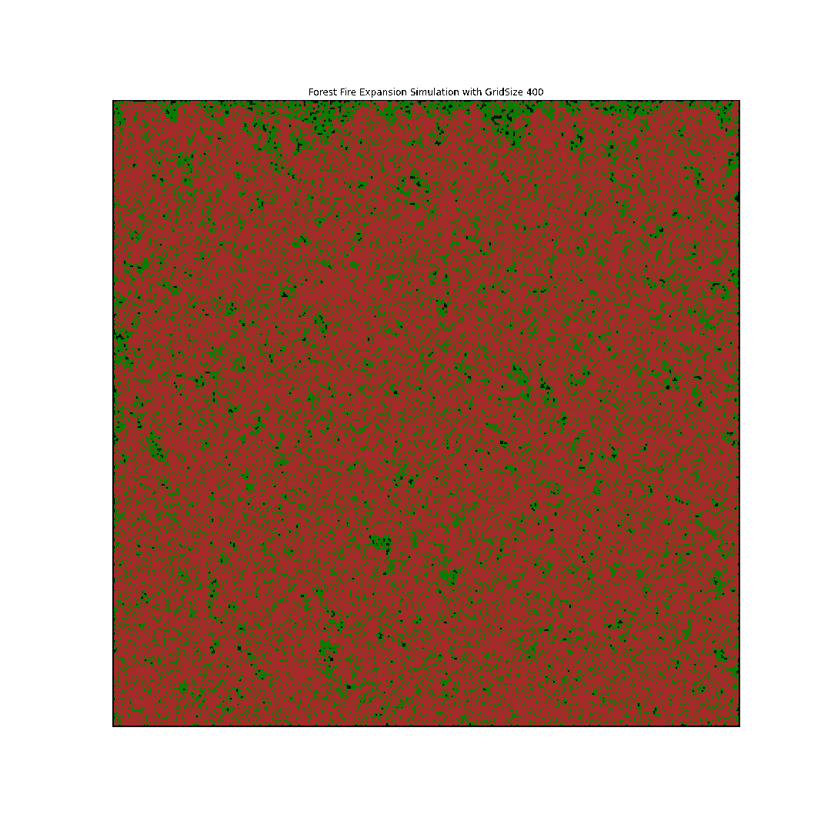

The forest grids was initialized using the Numpy python library and displayed using the Matplotlib library. Being a cellular automation simulation (Shiflet & Shiflet, 2006), each cell in the forest grids interact with each other, and could cause a change in cell state, — that is, a fire. However, before initializing the forest site, I declared the variables for the different cell states and probabilities as seen in the image below. The cell states are the forest border, free land, tree and trees on fire depicted using the numeric values 3, 0, 1, and 2 respectively in the forest grid.

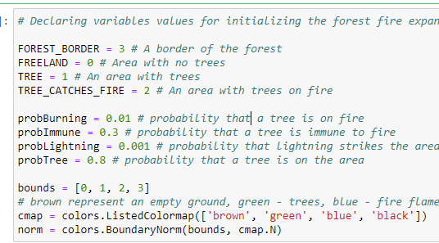

Upon declaring the variables for those cell states and probabilities, the forest grid was initialized under the following conditions

* That the position of the cell states is a product of chance, hence, the Monte Carlo randomized approach (Gentle, 2003) was used to mathematically determine the probability that a tree or burning tree on fire was existing initially at a location.
* That a tree existing at a location is a condition for the existence of burning trees at that location.
* That for forest grid locations where there are no trees, a value representing a free land is assigned to it, showing it’s an empty area.

See the image below for the **fillTheNewForestSite** function responsible for initializing the forest grid using the conditions listed above.

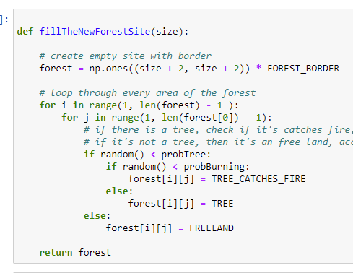

Having initialized the forest grid, I created another function to help extend the boundaries of the forest by creating ghost cells around the forest boundaries. These essence of creating these ghost cells is to provide neighbours to cells at the borders of the forest grid. This step was important because one of the requirements for the expansion of the fire, is the existence of a tree at any of its Moore neighbours. That is, cells at the north, south, east, west, south east, south west, northwest and north east. The function responsible creating the ghost cells at the boundaries is called the **applyPeriodicBoundaryConditions()** and is displayed below.

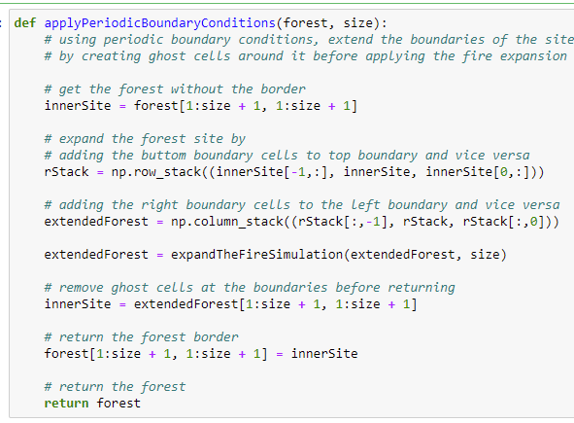

Upon successful completion of extending the boundaries, the expansion rules are applied as stated below.

* A tree will catch fire if it’s not immune and one of the cells in its Moore neighbourhoods is on fire. Otherwise, it’s won’t catch fire.
* A tree will catch fire if it is not immune and lightning strikes the site. Otherwise it doesn’t burn
* A burning tree burns to the ground and the cell in the grid is assigned the value of a free land.
* Free lands remain the same.

The implementation of the fire expansion is displayed in the image below.

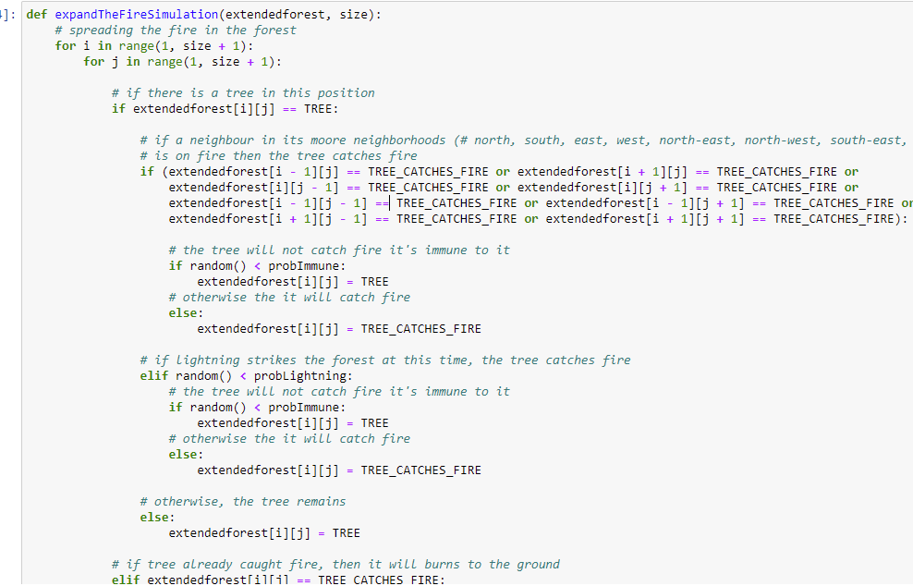

Visualization

Visualization of the forest grid was done with Matplotlib that displays the forest grid and executes the applyPeriodicBoundaryConditions and expandTheFireSimulation functions for every iteration in the animation.

Here is an image showing the result of the 100 by 100 forest grid size. More gif images have been submitted with the assignment.



# Methods and Result Evaluation

To allow comparison between the parallel and sequential implementations, the time diff

|  |  |  |
| --- | --- | --- |
| Forest Grid Size | Sequential | Parallel |
| 100 X 100 | 0.073 | 0.064 |
| 400 X 400 | 0.86 | 0.77 |
| 800 X 800 | 3.45 | 3.00 |
| 1000 X 1000 | 5.71 | 4.74 |
| 1200 X 1200 | 7.85 | 7.29 |
| 2000 X 2000 | 22.1 | 20.83 |

The simulation was executed at the university computer lab.

The above simulation compares the execution time of sequential and parallel cellular automation models to demonstrate the performance gains of executing simulations sequential and concurrently among computer processing units. As shown in the chart above. The parallelization improved the execution of the simulation.

# Future Recommendations

I recommend trying out larger forest grid sizes with parallelization and if possible it should be done on a larger screen, so that the animations can display properly.

# Bibliography

Gentle, J. E. (2003) *Random number generation and monte carlo methods*, Second edition. London; New York: Springer.

Shiflet, A. B. & Shiflet, G. W. (2006) *Introduction to computational science: Modeling and simulation for the sciences*. Princeton; Oxford: Princeton University Press.